***HOSPITAL MANAGEMENT SYSTEM***

***Submitted by***

**L.KEERTHANA(192112075) ,**

**J.BHAVITHA(192111033).**

***In partial fulfillment for the completion of the***

**Project**



**Department of PROGRamming**

**SAVEETHA SCHOOL OF ENGINEERING**

**SAVEETHA INSTITUTE OF MEDICAL AND TECHNICAL SCIENCES,**

**CHENNAI – 602 105**

**SEP 2022**

**SUPERVISED BY**

**Dr. Vijay Bhaskar**

**BONAFIDE CERTIFICATE**

This is to certify that the project report entitled **“HOSPITAL MANAGEMENT SYSTEM”** submitted by " L.KEERTHANA (192112075), J.BHAVITHA (192111033)” to Saveetha School of Engineering, Saveetha Institute of Medical and Technical Sciences, Chennai, is a record of bonafide work carried out by him/her under my guidance. The project fulfills the requirements as per the regulations of this institution and in my appraisal meets the required standards for submission.

**Dr. Vijay Bhaskar**

**Department of Programming**

**Internal examiner External Examiner**

**ACKNOWLEDGEMENT**

I take immense pleasure in expressing my gratitude to our Honourable Chancellor**, Dr. N. M. VEERAIYAN** for being our constant source of inspiration.

I sincerely thank our Vice-Chancellor, **Dr. L. JAWAHAR NESAN** for providing the academic ambience to complete the project successfully.

With profound gratitude, respect and pride, I express my sincere thanks to our Director, **Mrs. RAMYA DEEPAK**, whose enthusiasm and dynamism being the driving force behind all our accomplishments.

I take this opportunity to extend our heartiest thanks to our beloved Principal, **Dr. Ramesh** for providing us excellent facilities and unstinting support which were the sustaining factors in carrying out the work successfully.

I owe a deep sense of gratitude to **Dr.K.Vijaya Bhaska**r, Department of Programming, for his keen interest on me at every stage of my project.

It is a genuine pleasure to express my deep sense of thanks and gratitude to my mentor Dr. Sungeetha Asst.Prof/Asso.Prof, Department of Nanotechnology. His/her dedication and keen interest had been solely and mainly responsible for completing my work.

Also, I am greatly indebted to my project guide **Dr.K.Vijay Bhaskar** Department of Biotechnology. His timely advice, meticulous scrutiny and scientific approach have helped me to a very great extent to accomplish this task.

Last, but not least, a very special thanks to my parents and friends for their moral support and care extended during the demanding times.

**ABSTRACT:**

Hospital Management System is an organized computerized system designed and programmed to deal with day-to-day operations and management of hospital activities. The program can look after inpatients, outpatients, records, database treatments, status illness, billings in the pharmacy, and labs. It also maintains hospital information such as ward id, doctors in charge, and department administering. In this project, we are going to provide the extra facility to store the report in the database and make it available from anywhere in the world. The purpose of this study is to develop a computerized hospital management system that will upgrade the quality of information management and efficiency of the hospital employees using this study. The study was able to produce the module that would administer patient registration and admission details; a module that would manage the admission bills and pharmaceutical payments; and a module that could monitor medicine inventory of the hospital pharmacy. Healthcare is so interesting for our society. Hospital Management Information System (HMIS) is a computer-based system that has the ability to coordinate all information for enable healthcare providers to do their works effectively and efficiently. According to using these systems across the globe, this requires a strong need to understand such systems and its capabilities. This work conducts investigation study about hospital management information system encompasses historic view of the system and its evolution stage, the most important functionalities services, stakeholder of such system, components of HIS, three layer graphic based model(3LGM), architecture design style of HIS and standard communication of HIS. This work will give a comprehensive picture to the reader about available HMIS. E. It deals with the collection of patient’s information, diagnosis details, etc. Traditionally, it was done manually. The main function of the system is register and store patient details and doctor details and retrieves these details as and when required, and also to manipulate these details meaningfully. System input contains patient details, diagnosis details, while system output is to get these details on to the screen. The Hospital Management System can be entered using a username and password. It is accessible either by an administrator or receptionist. Only they can add data into the database. The data can be retrieved easily. The data are well protected for personal use and makes the data processing very fast. Patient in a hospital environment need to visit various resource forms sequentially that they can undergo or be diagnosed with medication The primary objective of these problems is to allow the services in their subset to be visited by each individual within the allocated time.

**INTRODUCTION:**

The project Hospital Management system includes registration of patients, storing their details into the system, and also computerized billing in the pharmacy, and labs. The software has the facility to give a unique id for every patient and stores the details of every patient and the staff automatically. It includes a search facility to know the current status of each room. Users can search the availability of a doctor and the details of a patient using the id. The Hospital Management System can be entered using a username and password. It is accessible either by an administrator or receptionist. Only they can add data into the database. Human Body is a very complex and sophisticated structure and comprises of millions of functions. All these complicated functions have been understood by man him, part-by-part their research and experiments. As science and technology progressed, medicine became an integral part of the research. Gradually, medical science became an entirely new branch of science. As of today, the Health Sector comprises of Medical institutions i.e. Hospitals, hospitals etc. Research and development institutions and medical colleges. Thus the Health sector aims at providing the best medical facilities to the common man. Still being a developing nation India has seen a tremendous growth of the Health sector in the field of research as well as in the field of development of numerous large and small scale Hospital institutions still lacking in inter-structure facilities. Government of India has still aimed at providing medical facilities by establishing hospital. This system should include many features in the online front that include the patients records including his disease history and reports. Above mentioned data can be accessed by the respective doctor from anywhere around the globe. The storage of all these details would be done by setting up a database server. If a patient is admitted to the hospital, all the vital details would be updated for the doctors to check it online. They can even give online prescriptions directly to the pharmacy specific to a particular patient with their patient id. Every person who visits the website can register themselves as a patient and get an unique Patient ID that is referred to in all the future transactions. A patient can take the appointments online and know the availability of the doctor. Notifications regarding the regular health check-ups and medicine reorders. Hospital information system was defined as an integrated computer system to store, manipulate, manage and retrieve clinical, and administrative information in healthcare organization.

**LITERATURE REVIEW 1:**

**International Journal for Research In Engineering Application & Management (IJREAM), Author-** **Musa, A. Lancashire Bus. Sch., Univ. of Central Lancashire**

**ISSN: 2494-9150 Vol-01, Issue 11, FEB 2016**

One of the major challenges existing hospital management systems face is around operational efficiency and wait times between different processes, departments and persons. This paper highlights such limitations of existing systems and proposes a RFID(Radio Frequency ID) and wireless sensor based , location and information management framework that facilitates real time tracking of hospital assets, personnel and patients as they move through pre-set procedures as part of daily activities of the hospitals. This system covers the visual simulation and providing ability to analyse the ongoing operations so they can be corrected to achieve increased process efficiency and service levels.

**LITERATURE REVIEW 2:**

**International Journal of Advanced Research in Computer and Communication Engineering Iso 3297:2007 Certified Vol. 6, Issue 1, January 2017**

Generally Hospital management information systems have the function of patient are and hospital management. These functions include: keeping information about the patients, generating bill, maintenance schedule of equipments in the hospital, recording information related to diagnosis given to patients, keeping record of the immunization provided to patient, keeping information about various diseases and drugs available to treat them etc. Previously, all these different functions are done by operational cadre and doctors manually on paper. With the increase of demands on health care services because of increasing in population paired with increasing attention over patients' safety and the way to treat them, it became so hard to do all these works manually.

**LITERATURE REVIEW 3:**

**Hospital Management System Using Web Technology,**

**Published: June -2020; Assistant Professor, Lakshmi,**

**Reva University, Bengaluru, India**

The primary objective of this project is to define, implement and build a system which offers support for the hospital management, that can be fulfilled only thorough achieving the secondary objectives that will be presented next. One of the objectives of this project is to enhance the efficiency in usage, that is measured through the expressivity and the consistency of the graphical user interface. A user is considered to be efficient when using a system if the time necessary to execute a certain task decreases with each usage. Another objective is to create a system that allows further improvements, extensions of the current functionality. The system should be able to offer the opportunity to manage patient details, doctor’s details, schedule appointments, view prescriptions, order medicines online and make online payment.

**LITERATURE REVIEW 4:**

**Hospital Management System, Published : May 2018**

**Matarlo, Marlou J. And Oniot John Barth**

**Southern Philippines Agri-2bussiness**

Hospital Management System is powerful, flexible, and easy to use and is designed and developed to deliver real conceivable benefits to hospitals. Prasanth and Sailaja (2014) stated that hospital management system is to computerize the front office management which deals with collection of patient information, diagnosis details, and even the billing details. The researchers have found out that the computerization of hospital management system has become a necessity and has become the new standard. By implementing this technology adoption, the researchers also found out that the need of easy access to patient information and history are significantly increasing. management is a significant part of today’s cost and quality crisis in health care. This is the reason why suitable hospital needs and appropriate medical management must be present to deliver applicable healthcare facilities.

**LITERATURE REVIEW 5:  
Hospital Management Maturity Models  
Published: October 2021,Luciano Trentin, Gerson Tontini**

The maturity model has become an established and important instrument to guide organizational transition initiatives (Batenburg, Neppelenbroek, & Shahim, 2014). Maturity models are established on the principle of periodic growth stages, in which the changes of an organization over time, are organized in a continuous and calculable way, covering an established number of cumulative and orderly continuous stages, which can be described and related to an established level of maturity. The hospital segment is a complex, dynamic and specialized ecosystem, and the establishment of thoughts through processes and its effective management requires the right tools and the support of a mature organizational culture. It is necessary to establish a modern management model that supports decision makers, with the purpose of improving processes, systems and hospital management, considered as a complex organization. Thus, it should be put in front of relevant models for assessing organizational maturity and determine the points of improvement, gradually revealing the consecutive improvement of these organizations.

**Methodology**:

There are two modules that are identified, Patient and Doctor modules. The patient module is used to book appointments, make payments, view reports and see their medical as well as payment history. The patient module also contains a disease prediction section where the patients Whereas the doctor module has the User Interface(UI) for the employees to access the database. There are four types of users in the Doctor module. They are Admins, Doctor , Lab staff and Pharmacy staff. They all have hierarchical access to the database. Admin is responsible for adding the users to the database and giving access based on their designation. Users with Doctor access can view his patients details, give medicines and view the tests assigned to him. Lab staff are incharge of the payment section and reports. Pharmacy staff can add or remove the medicine details and dispatch the medicines based on the payment details.

**PIE CHART:**

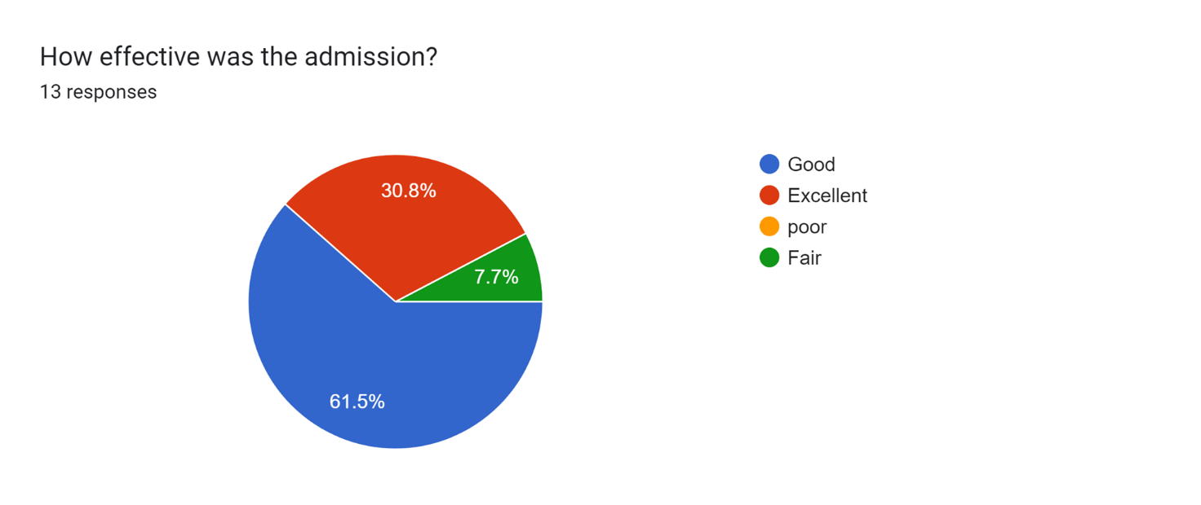

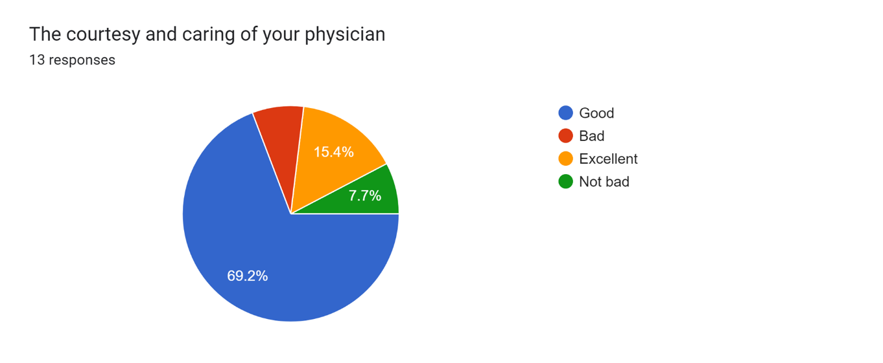

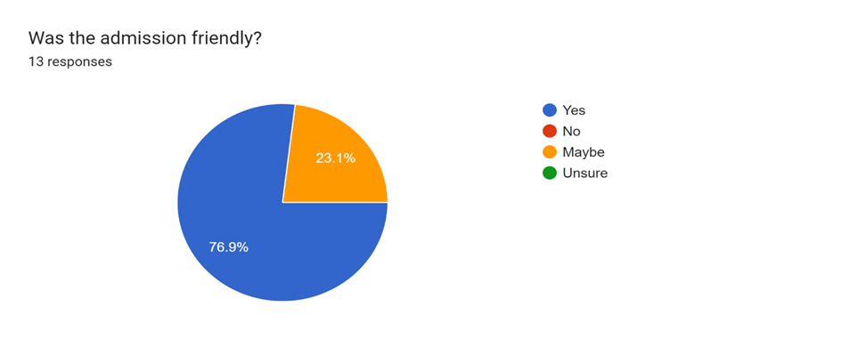

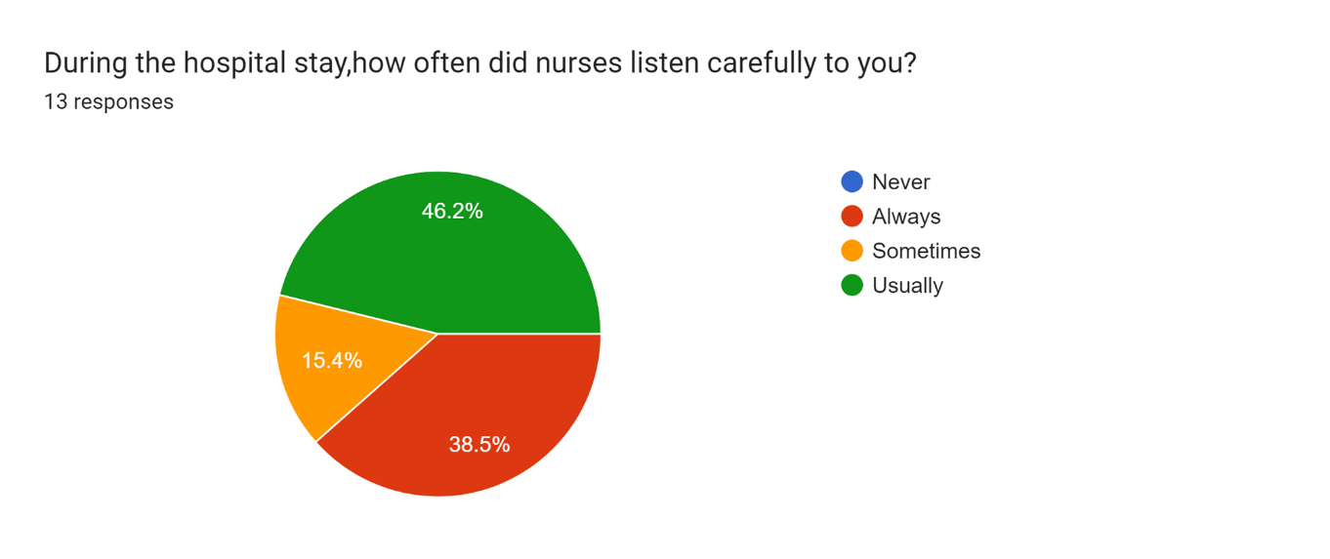

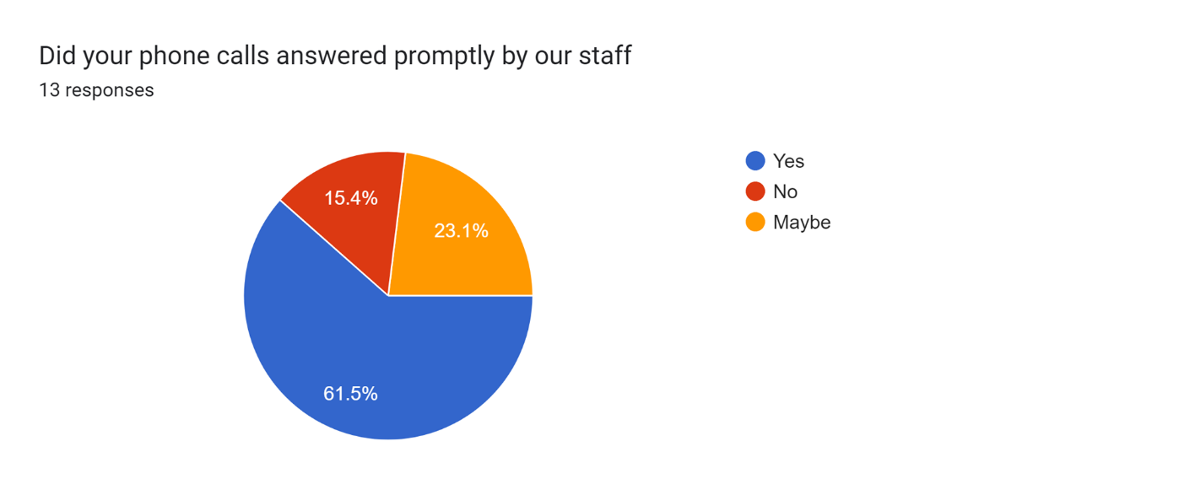

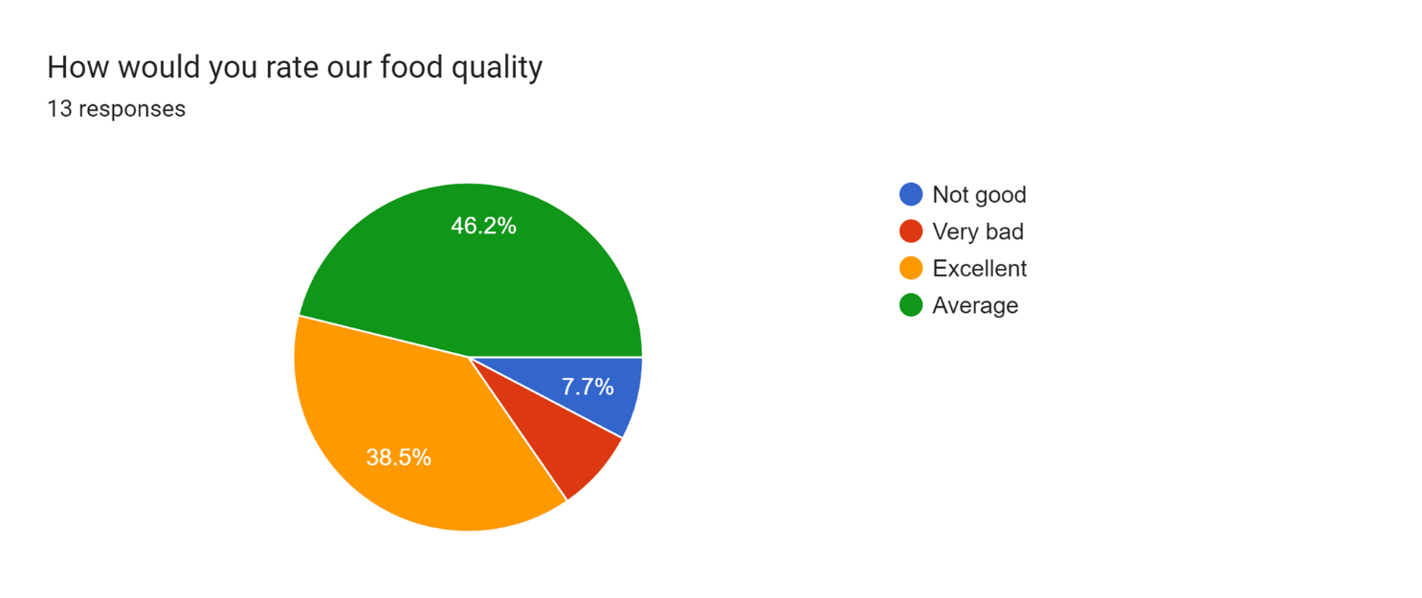

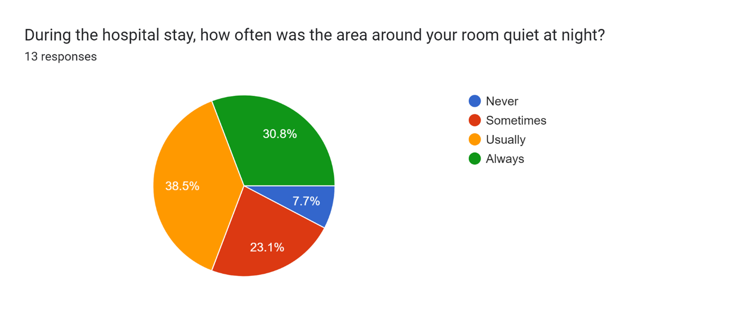

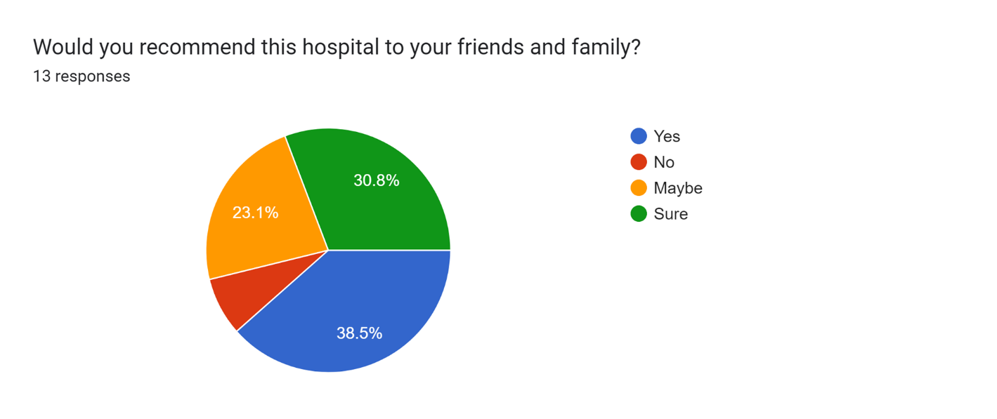

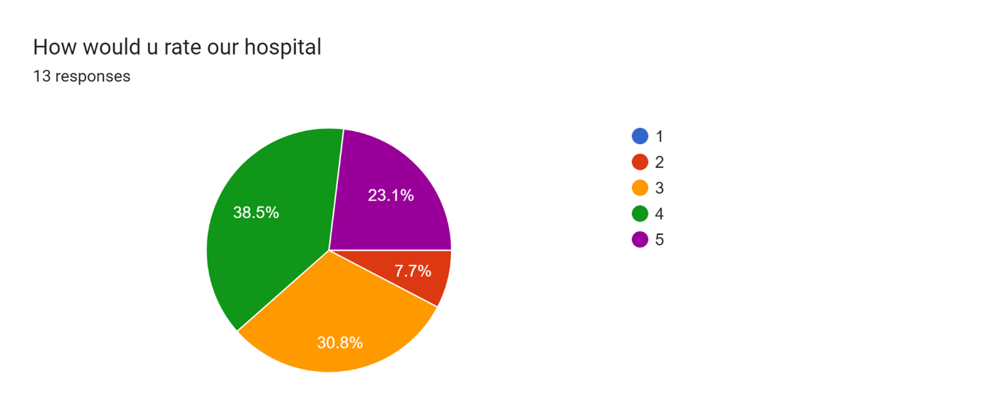

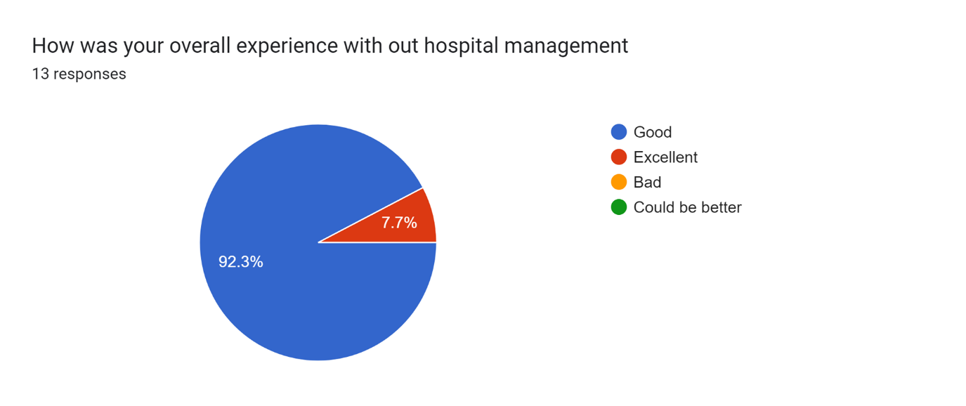

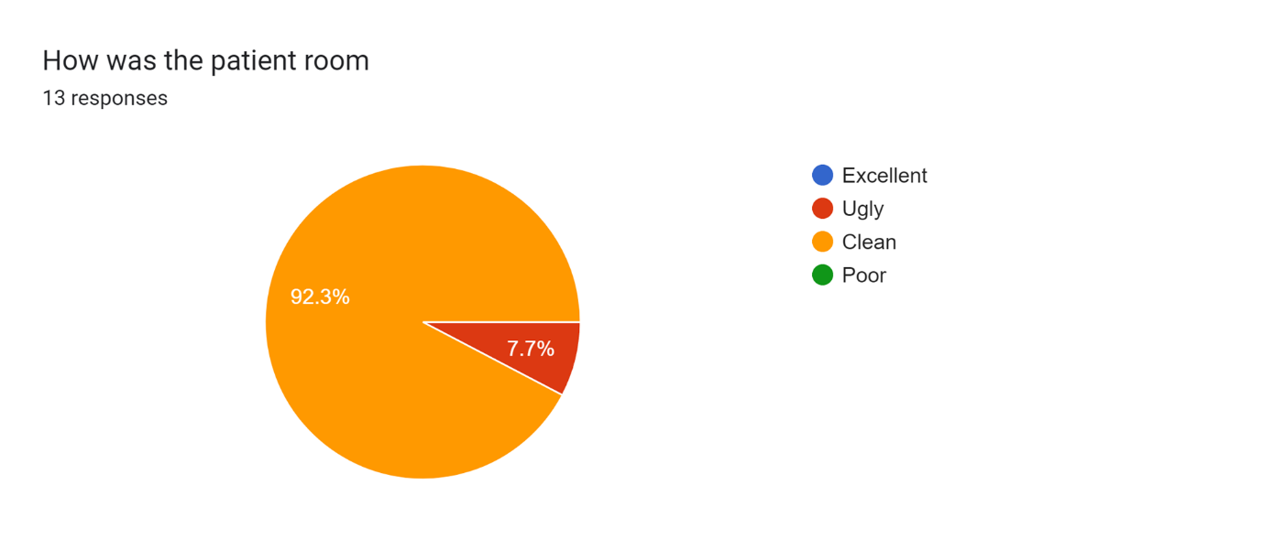

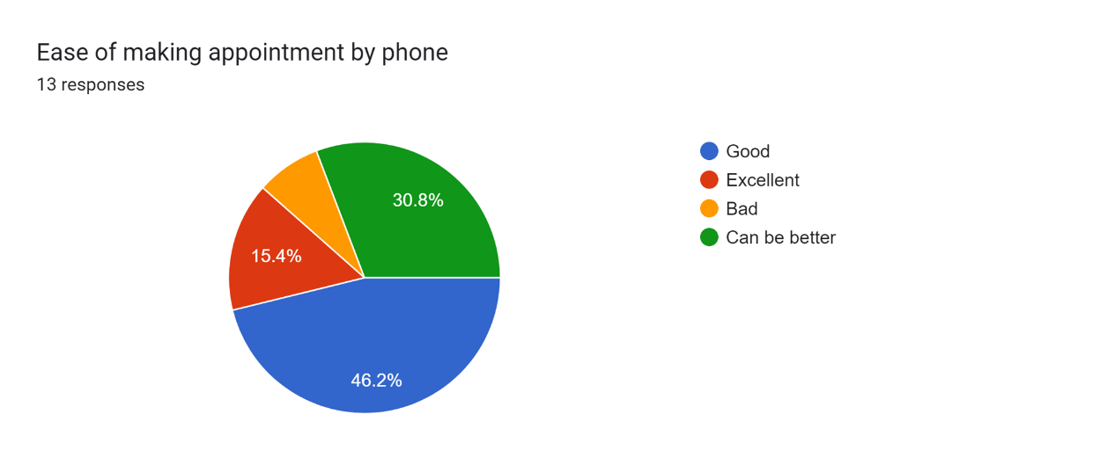

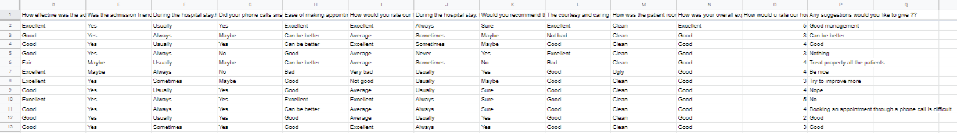

**OBSERVATIONS AND RESULT:**

The above conducted survey shows that the Management that is carried by the Hospital:

* It shows that the admission was effective and friendly
* It shows that during the hospital stay the nurses were friendly with the patients and the rooms were quiet at night
* It shows that the phone calls are answered promptly by our staff
* It shows that our patients overall experience is good in our hospital.

**MAIN OBJECTIVES OF A**[**HOSPITAL MANAGEMENT SYSTEM**](http://www.datamateuae.com/)**ARE:**

* Design a system for better patient care.
* Reduce hospital operating costs.
* Provide MIS ([Management Information System](http://www.datamateuae.com/)) report on demand to management for better decision making.
* Better co-ordination among the different departments.
* Provide top management a single point of control.**anat is carried by the**

**FEATURES OF HOSPITAL MANAGEMENT SYSTEM** **:**

Hospital management system (HMS) is a computer framework that makes a difference oversee the information wellbeing care and helps within the work completion of good care supplier successfully. They oversee the information related to all offices of healthcare such as

* Clinical
* Financial
* Inpatient
* Outpatient
* Laboratory
* Operation theatre**t shows that the a and the r**

**ADVANTAGES OF HOSPITAL MANAGEMENT SYSTEM :**

* Specifically, the integration of the software into the system has made communication much more effective in the case of the health care system. As a result, it is possible to access every data from anywhere in the world specifically via. authorized login. This mode of communication has become relatively cheaper.
* The effective usage of technology has contributed to minimizing many of the limitations. One of the biggest issues in the health care system is considered to be the geographical limitation.This has been effectively managed with the addition of the hospital management system. The integral reports can be sent through instant messages, emails, etc.
* In the case of the hospital management system, the information is available 24 hours throughout the week. This indicates that the reports can be sent anytime on any particular day.So, there is no such possibility for the delay in getting the treatment. Apart from that, the communication mode has become relatively cheaper. Therefore, no report will be delayed from reaching the hands of the authorities.

**DISADVANTAGES OF HOSPITAL MANAGEMENT SYSTEM:**

* One of the greatest disadvantages of the hospital management system is generally related to security. It is considered to be a matter of concern in case you go online without enough protection which can create some big problems related to security.
* Another greatest problem that is associated with the health care industry is the data breach. Not only that, but it is also known to be a sophisticated problem.
* Lack of employment is another such thing. The chances of employment usually become less with the automation of the system. Also, the gradual need for manual data drafting becomes an irrelevant aspect.

**PROBLEM STATEMENT:**

In this busy world we don’t have the time to wait in infamously long hospital queues. The problem is, queuing at hospital is often managed manually by administrative staff, then take a token there and then wait for our turn then ask for the doctor and the most frustrating thing - we went there by traveling a long distance and then we come to know the doctor is on leave or the doctor can’t take appointments. HMS will help us overcome all these problems because now patients can book their appointments at home, they can check whether the doctor they want to meet is available or not. Doctors can also confirm or decline appointments, this help both patient and the doctor because if the doctor declines’ appointment then patient will know this in advance and patient will visit hospital only when the doctor confirms’ the appointment this will save time and money of the patient. Patients can also pay the doctor’s consultant fee online to save their time. HMS is essential for all healthcare establishments, be it hospitals, nursing homes, health clinics, rehabilitation centers, dispensaries, or clinics. The main goal is to computerize all the details regarding the patient and the hospital. The installation of this healthcare software results in improvement in administrative functions and hence better patient care, which is the prime focus of any healthcare unit.

**CONCLUSION:**

Working on the project was an excellent experience. It helped us to understand the importance of planning, designing and implementation so far we have learnt in our theory books. It helped us unleashing our creativity while working in a team. It also realized the importance of team working, communication as a part of this project. The conclusion of this project is the Hospital Management System is essential for maintaining detail about the Doctor, Patient, Hospital staff etc. we understand that by using of Hospital Management System project the work became very easy and we save lot of time. Hospital administrators would be able to significantly improve the operational control and thus streamline operations. This would enable to improve the response time to the demands of patient care because it automates the process of collecting, collating and retrieving patient information. Accounting sometimes becomes awfully pathetic and complex. This product will eliminate any such complexity. In these method the Patient’s not to go hospital for booking. The Patient only need internet for booking purposes and hospital individual doesn’t have direct contact while booking. Both of them can adjust their schedule time through online. The system get rid of the issues appeared during traditional booking system. It is understood that on the introduction of the Hospital Management Project into play , the work at the hospitals would be seamless and efficient. Transferring the patient data would take only seconds compared to the traditional way of sending the file manually. Usually boring and mundane accounts work will also be automated and simplified. Hospital administration is getting quite popular as a career option,and more and more people are going for it. Hospital administrator is in unique position to help ,create an environment for the doctor and other healthcare force to work conviently with satisfaction,in an equipped and adequately staffed premise.Without the leadership role of a competent Hospital Administrator,a hospital is like ‘a ship in the vast ocean without a compass’.

**REFERENCES:**

[1] Herbert Scheldt, Java Complete Reference, Fifth Edition, Tata McGraw Hill Edition.

[2] Phil Hanna, JSP 2.0: The Complete Reference, Tata McGraw Hill Edition.

[3] Elmarsi and Navathe, Fundamentals of Database System (Third Edition), Addision Wesley.

[4] Ian Somerville, Software Engineering, Third Edition, Pearson Education

[5] Ali Bahrami, Object-Oriented System Development, Third Edition, Tata McGraw Hill Edition.

[6] R.S Pressman, Software Engineering: A Practitioner’s Approach, Mc-Graw-Hill, Edition-7

[7] P. Jalote, an Integrated Approach to Software Engineering, Narosa publication house, Edition

[8]Ogunseye Abiodun. A, “Design and Implementation of Hospital Management System Using Java”. IOSR Journal of Mobile Computing & Applicatio0042.Volume 2.

[9] Gunjan Yadava “ Advanced Hospital Database Management System” International Journal of Advanced Research in Computer and Communication Engineering Vol. 5.

[10] GB. Koyuncu and H. Koyuncu, "Intelligent Hospital Management System (IHMS)," International Conference on Computational Intelligence and Communication Networks (CICN), Jabalpur,